Module 2: Baseline Assessment

Session 17: Analysing Baseline Information

Handout 2 – Cross Checking Exercises

There are a number of things that can be cross-checked during the baseline analysis to ensure that the information collected in interviews is internally consistent. The aim of the following exercises is to give you the opportunity to practise identifying the different cross checks that can be done and the calculations involved.

- Income and expenditure cross checks
The extract below from a Baseline Storage Sheet shows summary data for four wealth groups in the Dry Middleveld Livelihood Zone in Swaziland. What cross checks could you do on the data shown?
Note that the results of the calculations that are carried out automatically in the Baseline Storage Sheet have been deleted here, for the purposes of the exercise.
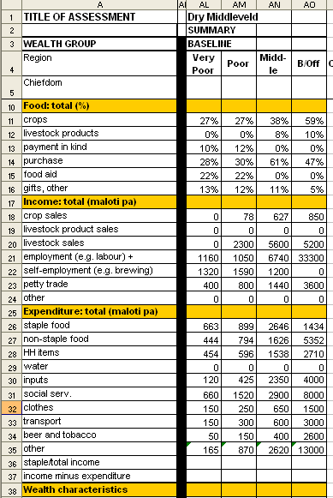

- Labour cross-check (i)
Background: A baseline HEA assessment is being carried out in the Sidama coffee livelihood zone (population about 182,000, with an average household size of 7). Wealth breakdowns show that the very poor make up about 15% of the population, and the poor about 25%. Lots of very poor households report that one household member (the man) typically works for three months of the year (October – December) at a coffee pulping station.

Further enquiry shows that there are 79 coffee pulping stations in the zone, each employing between 70 and 100 casual workers.

Question: Check how many people this casual work could support. Is it possible for most very poor households to obtain income from this source?

Tip: Use the type of cross check in which you imagine that there are 100 households in the livelihood zone, falling into the wealth groups according to their percentages.

- Labour cross-check (ii)
The following exercise involves another kind of cross check on casual labour, this time on the work carried out by the poor and very poor groups for the middle and better-off groups.

Background: Imagine there are 100 households in the livelihood zone, falling into the wealth groups according to their percentages. The very poor and poor provide labour; the middle and better off employ labour. In this zone, there isn’t much in-migration and most of the labour is supplied and employed locally. It is therefore possible to cross-check the total amount earned by the very poor and poor against the total amount spent by the middle and better off.

Question: Using figures from the table below, calculate whether the total amount earned by the very poor and poor is roughly consistent with the total amount spent by the middle and better off.

Labour cross check
Wealth group | Very poor | Poor | Middle | Better off
Number of households | 15 | 25 | 40 | 20
Labour status | Work | Work | Employ | Employ
Birr earned or spent per household | 560 | 370 | 100 | 600

- Land rental cross-check

Background: In another livelihood zone, poor households rent out their land to middle and better off households. The areas of land owned and cultivated by different wealth groups is shown in the table below.

Land rental cross check
Wealth group | Poor | Middle | Better off
Number of households | 50 | 30 | 20
Land owned per household (in timads) | 3.5 | 4 | 4
Land cultivated per household | 1 | 6 | 7.5

Question: Using the data in the table, check that the total land rented out and the total land rented in balances within the livelihood zone.

- Production cross-check: sweet potato

Background: The team in another livelihood zone wants to cross-check the crop production information they have for sweet potatoes. Some of the data they have is shown in the following table. In addition, the local agricultural expert has told them that the yield for sweet potatoes is about 1,750 kg per timad for all wealth groups.

Sweet potato production
Wealth group | Very poor | Poor | Middle | Better off
Total area cultivated (timads) | 0.75 | 1.25 | 2.25 | 4.5
Est. % land planted with sweet potatoes | 30% | 30% | 20% | 10%

Question: How would you use these figures to cross check with other production data obtained from interviews with household representatives?

- Income cross-check: coffee

Background: The team also want to cross check figures on coffee income calculated from production data with figures on coffee income obtained in interviews with household representatives. The data they have on coffee production is shown in the table below.

Coffee production (dry processed)
Wealth group | Very poor | Poor | Middle | Better off
Number of bushes | 12.5 | 25 | 50 | 90
Yield per bush (kg) | 0.9 | 1.0 | 1.1 | 1.2
Coffee price per kg = 4.5 birr / kg

Question: How would you use these figures to do a cross-check with income data obtained in interviews with household representatives?

